**Software Requirement Specification**

**(BFC Publications Chorus )**

**Table of content: -**

1. Purpose
2. Project Scope
3. Software tools
4. System Functionality
5. Module 1: PC (Publishing consultant) Dashboard.
   1. Add Leads.
   2. Create Packages.
6. Module 2: PM (Project Manager) Dashboard.
   1. New Projects
   2. Project in process.
   3. Completed Projects.
   4. Digital Marketing.

1. Module 3: Format Editor Dashboard.

1. New Projects
2. Project in process.
3. Completed Projects.

1. Module 4: Proofreader Dashboard.

1. New Projects
2. Project in process.
3. Completed Projects.

1. Module 5: Graphic Designer Dashboard.

1. New Projects
2. Project in process.
3. Completed Projects.
4. Module 6 : Author Support Dashboard.

1. New Projects
2. Project in process.
3. Completed Projects.

1. Module 7 : Digital Marketing Dashboard.
2. Module 8 : PCO(Project coordinator) Dashboard
3. Management Information System (MIS)

**Introduction**: - This document intends to present the proposed Modules, functionality, features, cost, timeline and respective for the website.

**Objective**

BFC Publication Chorus focuses on highly qualitative, timely delivered and cost-effective offshore e-Business Solutions development services With a rich and varied experience in providing software development, project management capabilities and stringent quality standards ensure to develop solutions that give your business an edge over your competitors. We are experts at developing and implementing applications for mission-critical and enterprise-wide projects.

**Purpose**

Purpose of the document is to define, gather and analyze all the requirements for development of BFC Publication Chorus.

**Project Scope**

In this, the overall working and main objective of the document and what value it will provide to customers is described and explained. It also includes a description of development cost and time required.

the possible outcome of a software system which includes effects due to operation of the program is fully explained. All functional requirements which may include calculations, data processing, etc. are placed in a ranked order.

**Software tools**

Following would be the Software/languages I would use to develop my application within the stipulated time period-:

1. Code Editor: Node Pad++, Sublime Text, VS code Editor.
2. Server: Apache Server, Host Getter.
3. GIT for Backup Storage.

The clearinghouse application will be built with PHP version 7, an open-source web scripting language. Data will be stored in a MySQL database, also open source. The user interface will be developed in HTML5, CSS3, and JavaScript. VUMC will be employing components from standard and commonly accepted libraries such as PHP Symphony and jQuery for JavaScript. PHP dependencies will be managed via the Composer package manager. The application will be able to run on any web server that supports PHP 7 and has a MySQL database. The ECSDWG will be responsible for securing the necessary server space. The application code will use Git version control, and all commits will be archived in a designated repository which can be made available to other ECSDWG members. Source code will be stored on a mutually agreed platform.

**System Functionality**

Functionality of the system is interconnected with all modules. Which is defines in each steps:

**Step-1:** Digital Marketer will get leads from social media and upload by their dashboard. (By Review, Filters, and removes duplicates leads then final submit).

**Step-2:** After upload leads, will show in sub admin`s dashboard (Vikas Singh) in wp allotment section as manuscript status. And he allotted leads to their respective PCs.

**Module 1 (P.C.D.B):**

**Step-3 :** PC can see all allotted leads.

**Step-4 :** PCs will consult their authors by using their contact details.

**Step-5 :** After getting all data from the author, the PC will fill all details in form and submit data.

**Step-6 :** PC can create or select existing packages(or customise) from the create package button and mail all the package details with payment link of the author for final approval.

**Step-7 :** Author will confirm their order and revert back with the same mail and make payment by the given link. And attached payment receipt along the mail.

**Step-8 :** After Confirmation from the author PC will acquire them by select status as acquired, by acquiring author, need to fill package related fields package cost, booking amount, first installment etc…

**Step-9 :** At last upload payment receipt from author, and submit the form.

**Step-10 :** Accountant can view all the leads from online and offline both as two different buttons that is -

1. Payment approval button

By clicking on the button he can see all  the leads of the author with the approve/pending button, after matching with their cashfree account, the accountant will change status as approved.

Lead list will show as following:

1. Project acquired by PC (with approve button for claim)
2. Project acquired online (Self acquired)

      2.  Pay Royalty button

By clicking on the button, the accountant can see all the book detail listings with pay royalty status so that he can pay the author`s royalty .

***-> if royalty is less than 500 then that details will not show in the accountant pay royalty listing.***

***-> to pay royalty one popup will open to fill amount details.***

**Module 2 (P.M.D.B):**

PM Dashboard will have following options:

1. New Projects
2. Project in progress
3. Completed Projects
4. Digital Marketing

**Step-11:** After approving a project from the accountant, PM can view all projects by status (new project).

1. **New Project List**

 New Project will have following header:

https://lh4.googleusercontent.com/v8KX8VvZckWm5gq4q6Q-a9UM42tCpSyCn1d16MJ_DAnRuDzwNf42PgoM39M6fIb90Ps-idwDXHyKSrkV0Rp1FBLR9ohHdXtpe8ZvEBWUmmODGjJmZyhMeEHs7g24nkEVRZ19ntkg

1. From send welcome mail & ASF (Author Submission Form) on click the button a mail will send to the author.
2. View ASF has a button to view the same ASF form.



1. Mail agreement button will enable after submission of ASF by Author.

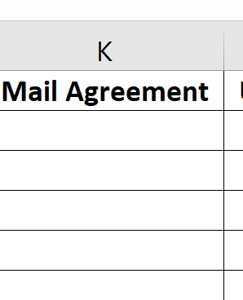

1. Mail agreement will have a predefined template having all basic details fetched by ASF form.
2. Mail agreement will be in PDF format & attached with mail after that author will download that agreement PDF, read and approved by revert back to PM.
3. After that, the approved agreement will be uploaded by PM & that will be sent to the author`s dashboard.
4. At last Take-up option will show for project starting.

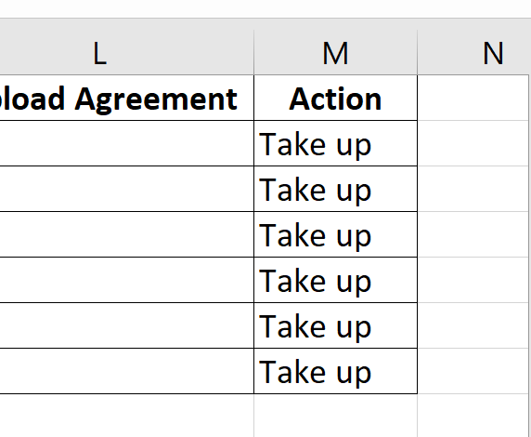

1. After Take-up particular project that will be listed on PIP (Project-in-progress) list. And will remove it from the new project list.



**2. PIP (Project in Progress)**

|  |  |  |  |  |
| --- | --- | --- | --- | --- |
| *Note -* |  |  |  |  |
| *1- Reminders will be given to the authors automatically on the due date.* | | | | |
| *2- Send printing quotation button.* | | | | |
| *3- Manuscript default option pending.* | | | | |
| *4- When ISBN is filled status will be changed to Received.* | | | | |
| *5- Payment Reminder button on PM dashboard.* | | | | |
| *6- Payment due reminder popup on dashboard.*     1. *1st reminder will be sent after 15th day of receiving manuscript* 2. *reminder 2nd, 20th day of receiving of MS.* 3. *Due date of reminder of final installment 30th day from receive of MS.* 4. *Due date for reminder 2nd, 35th day from receive of MS.* | | | | |
|
|

PIP project will have following header:

https://lh3.googleusercontent.com/4OjaFv7IHcjicG4_qt4vCGAqbwJzRsaADnvxm56bqm0wUoe8MDPrhGCr_QPMZYmTIGJz3ZKpb-ge2tHAp8OCMZtrJeZqOlm2F3n_QjQefkak_KcL2qIhRCmTdtPRBApd_eDiN9VD

*Note -*

*1- Reminders will be given to the authors automatically on the due date. 2- Send printing quotation button.*

*3- Manuscript default option pending.*

*4- When ISBN is filled status will be changed to Received.*

*5- Payment Reminder button on PM dashboard.*

*"6- Payment due reminder popup on dashboard.*

*1st reminder will be sent after 15th day of receiving manuscript*

*reminder 2 20th day of receiving of MS.*

*Due date of reminder of final installment 30th day from receive of MS.*

*Due date for reminder 2 35th day from receive of MS."*

*7- Printing quotation sent button will be available when balance payment is zero if format is paperback and hardcover.*

*8- When balance is zero enable button KDP,Google Play Books, Kobo for listing.*

1. After listing in PIP projects ISBN, MS, Mail MRP suggestion will show as pending status.
2. In-progress project MRP Suggestions will be sent to the author.
3. Mail MRP Suggestions (editable at the time of send to author on email) will be sent to author, author will approve by mail after fill main final MRP amount by PM for particular project, MRP suggestion status will be done.

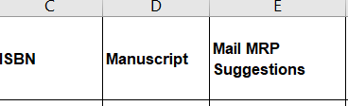

1. PM will select a particular project for working and distribution of work to the backend team.
2. On click to project A, PM will go to that project View on their dashboard.

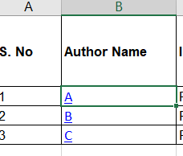

Project listing will show like this

1. By going to project A there will be a hyperlink to that particular project details, there will be a form to distribute the work to the backend team. And that will show like this.

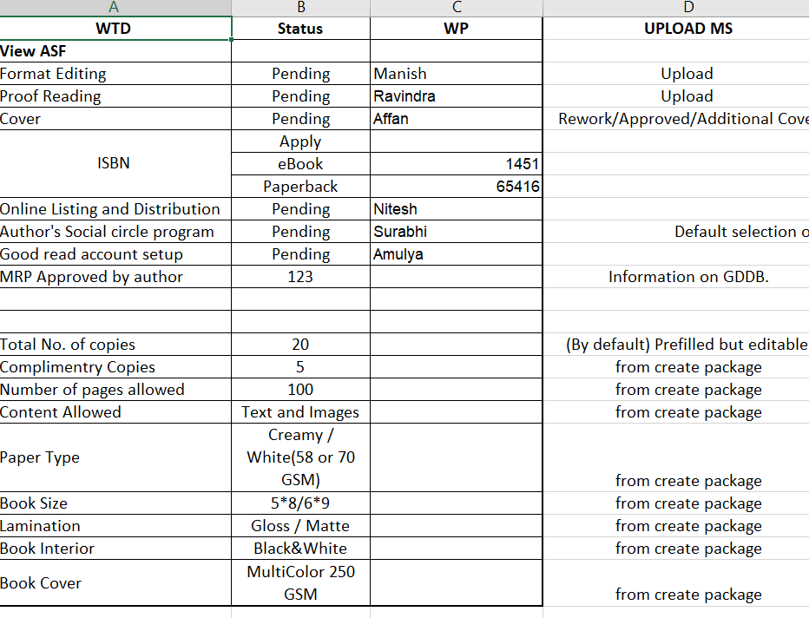

1. At the time of work distribution PM will decide whom to give work by checking all backend team`s older work report as well as take up projects.

1. PM can view all the work details of all the backend team by click on their name as Shown in diagram below:

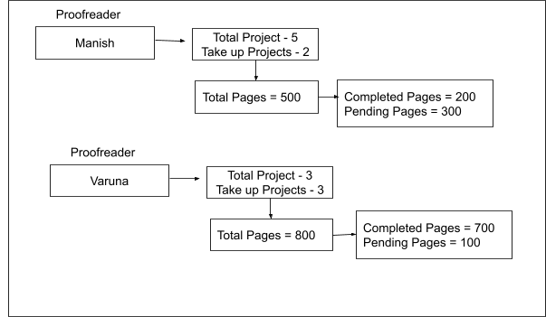

1. After checking PM will give a project to the team member who has less number of pages(Varuna) to be worked on at that time.

***Same thing will repeat to rest of backend team as Format Editing, Cover Designing, etc.***

**Step-12 :** Backend team will receive project for work from PM and they can start working as per their requirement.

**Module 3 (P.R.D.B) :**

**Proofreader Dashboard Working**

1. After getting a project from PM, proofreader will get a notification for a new project assignment.
2. Project detail will show like this:

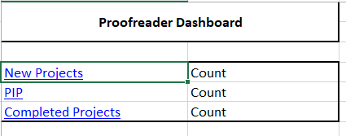

1. Going through the new project click proofreader will redirect to the all new project list.

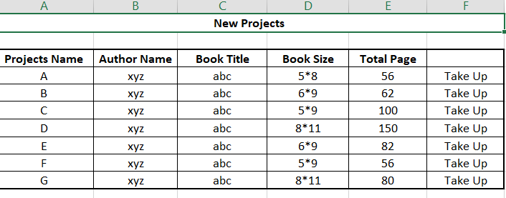

1. All projects listed like this, there will be all details of a project with author name, book title and all.
2. All Pages will be displayed on every project to be worked with a takeup button, after clicking on the takeup button project will go to the PIP list and remove from the new project list.

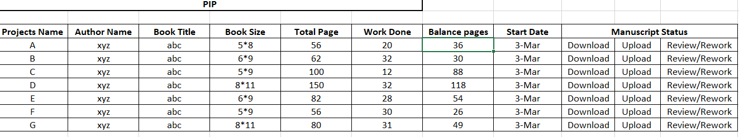

1. PIP projects will show with starting pages, work done and balance pages etc:

1. ***Proofreader will download the  manuscript for working by clicking on the Download Button then an icon for "Upload Manuscript" will automatically be enabled next to the Download button for uploading manuscript after the working is done.***
2. ***Proofreader will complete his working on the file and will upload the file through "Upload Manuscript Icon"***
3. ***After being uploaded, manuscript will remain under review till the further intimation by PM***
4. ***After manuscript is approved by PM's Dashboard it will shift to Completed projects and will disappear from PIP***

1. Proofreaders will have to react out their per day limit by completing fixed (70pages) pages per day.
2. At the time of logout they will receive an alert for reaching per day limit of pages work (Daily MPL).
3. After completing one project from their end they will upload MS for review after confirmation that project will go on completed project.
4. If there will be rework then it would remain in PIP until further work is done.

**Module 4 (F.E.D.B) :**

**Format Editor Dashboard**

1. After getting a project from PM, Format Editor will get a notification for a new project assignment.
2. Project list will be shown as above dashboard lists.
3. After Takeup project that will be listed out in PIP.
4. In PIP lists project lists with all details along daily MPL.
5. There will be an additional option for download/upload MS before and after work is done.

1. ***Format Editor will download the  manuscript for working by clicking on Download Button then an icon for "Upload Manuscript" will automatically be enabled next to Download button for uploading manuscript after the working is done.***

***Format Editor will complete his working on the file and will upload the file through "Upload Manuscript Icon"***

1. ***After being uploaded, manuscript will remain under review till the further intimation by PM***
2. ***After manuscript is approved by PM's Dashboard it will shift to Completed projects and will disappear from PIP***
3. ***Notifications related to reworking files should popup on the dashboard.***
4. ***Notification for approved project.***
5. ***Upload MS button will be enabled only when the balance pages are nil.***
6. ***After uploading MS a notification should popup on PMs dashboard.***
7. ***The latest uploaded MS shall remain in the database.***

1. After work done from their end editor will upload MS for review that will revert with okay or rework status.
2. After completing the project that is listed out in completed project list.

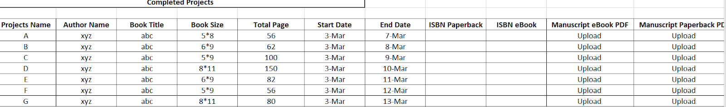

1. In completed project list there will be an option for ISBN Paperback and eBook
2. When PM will allot ISBN paperback and eBook it will appear in the respective column.
3. After completing work MS of PDF and eBook will be uploaded so the upload button will be active after approval of the project.
4. When FE will upload MS final file an notification will display on PM dashboard for final file upload.
5. After that PM will revert back with a notification as final file recieved.

**Module 5 (G.D.D.B) :**

**Graphic Designer Dashboard**

1. After getting a project from PM, Format Editor will get a notification for a new project assignment.

1. 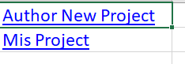
2. GD will have two options :
3. Author new project
4. Misc. Project
5. Misc. project will be miscellaneous projects that can be provided by Ashish, Shivangi, Vikas, technical team etc.
6. In misc project list options will be like :

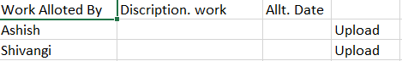

1. Work will alloted with a short description and alloted date, and an upload button by clicking GD will upload their work after done.

1. After clicking on the new project GD can see all the ew projects with details.

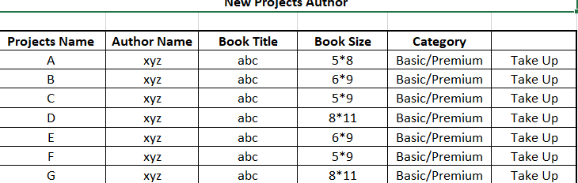

1. There will be details of the new project with book size and category .
2. GD can take up the project for start working after that project will listed out in PIP.

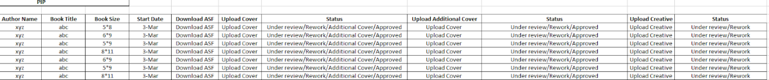

1. In PIP list all there will be option for download ASF(Author Submission Form).
2. Graphic Designer will download the  ASF for working by clicking on Download Button then an icon for "Upload Cover" will automatically be enabled next to Download button for uploading Book Cover.
3. Graphic Designer will complete his working  and will upload the Book Cover through "Upload Cover" button.
4. After being uploaded, Book Cover will remain under review till the further intimation by PM.
5. After Book Cover is approved by PM's Dashboard it will shift to Completed projects and will disappear from PIP.
6. Notifications related to reworking files should popup on the dashboard.
7. Notification for approved project.
8. When status is approved upload creative button will enable.
9. Additional cover button on PMs dashboard.
10. Enable upload additional cover button when status changed by PM.

1. After GD work is done the project will be listed out in the completed work list.

1. The Upload button will be active after approval of the project. Final file notification on PMs dashboard.

1. The moment isbn and mrp is flashed on the GD's dashboard, GD will do the required work in the cover and will upload the Book Cover through upload button

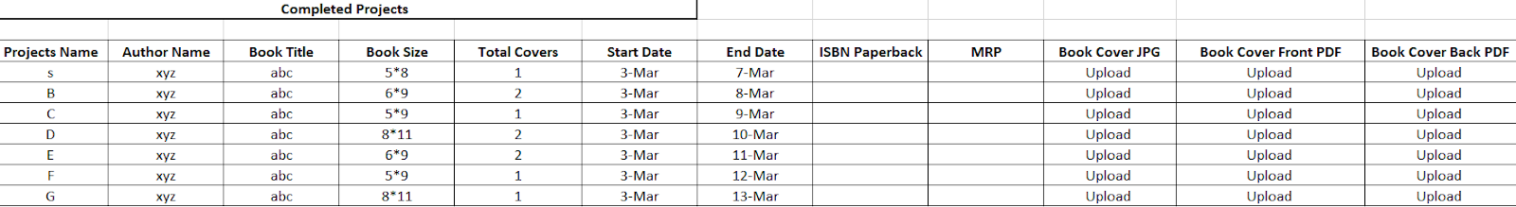

ASF form will be as follows:

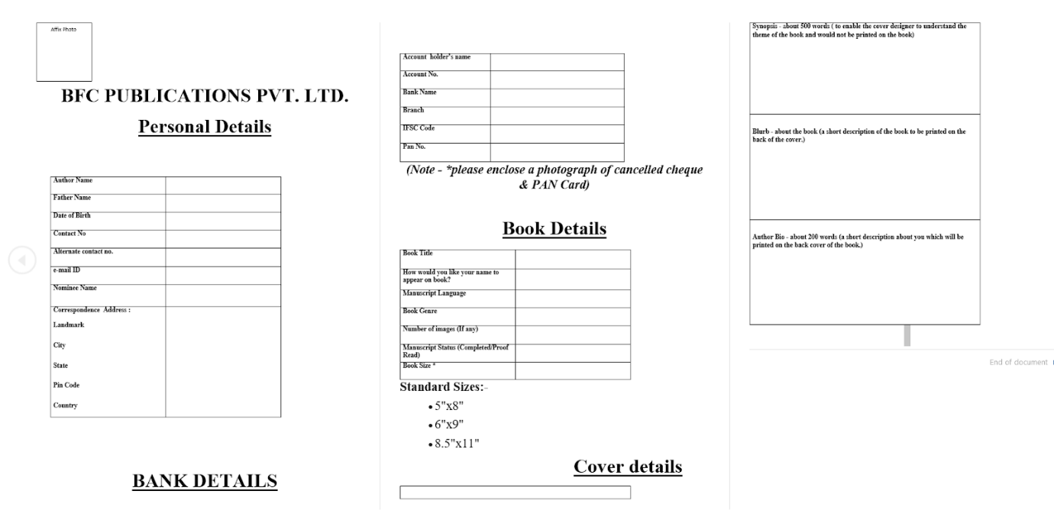

***-> At every step of leads upload and project acquiring, a notification will be sent to all the backend team dashboard.***

Linking of all the Modules is defined with the flow diagram given Below:

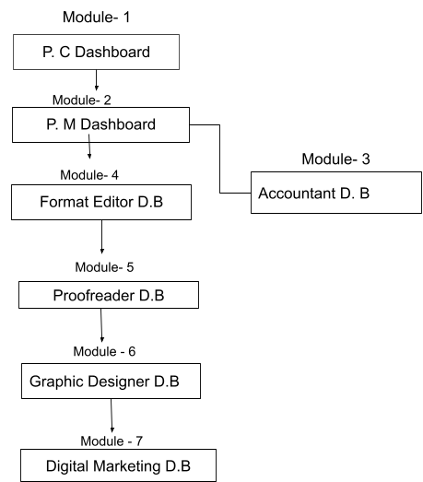

**DATA FLOW DIAGRAM**

From Social Media

Take Leads

Digital Marketing

Leads

Notification of leads

Sub Admin

**Module - 1**

**P.C.D.B**

Contact to author

Author Agree

Yes NO

Ask to author to choose package

Choose Package

Predefined Package

Customized Package

Author Choice

Author Choose selected package

Author revert to P.C with confirmation mail with payment

**Module- 2**

**Accountant**

PC will upload pay receipt of author

PM can see agreement enable after receive ASF

After Confirmation P.M will take up that Project

View ASF

Revert ASF form with confirmation

Send ASF to Author

Author

**Module- 3**

**P.M. D.B**

Not Matched

Match

Confirm Payment

PIP

(Project in Progress)

Take project for working

Receive Notification

Choose One from

If Choose Format Editor

If Choose Proofreader

Start Working of format editing and upload MS after work is done from their side

Download MS

New Project

New Project

**Module – 5**

**P.R.D.B**

**Module – 4**

**F.E.D.B**

MPL

Process all their work on project

Start Work

New Project

**Module – 6**

**G.D.D.B**

If Approve

Rework

Deadline match

Upload Additional

cover

If Rework

Cover Process

Upload Cover

Download ASF for cover design

**Module – 6**

**G.D.D.B**

If MS Approve

Rework if not approve

Notification to PM

P. M.D.B